Games Design Document

Enter the Drunkgeon

Contents
High Concept 3
Overview 3
Game Loops 3
Game Pillars 3
Environment 3
Genre 3
Game Mechanics 5
USP 5
Player Characteristics Outline 5
Target Audience 5
Level Design Documentation: 6
Goals of level & key areas 6
Story 6
Focal Points 6
Lighting 6
Visual Development 6
Colour Palette 7
Level Design Plans 7
Sketch Map 8
Level Design Map 8
Blockout 8
Focal Points 8
Level flow 9
Player Characters, Controls and Abilities 11
Player Controls and Map 11
Player Camera 11
Character/s background 11
Character/s Mechanics 11
Weapons and Pickups 13
Projectile Description 13
Weapon Stats 13
Game Conditions 15
How do you win? 15
How do you lose? 15
Can you die? 15
Mission Flow 15
Rewards and Progress 16
Score such as multipliers, kills, kill count, collection based. 16
Enemy Density 16
UI Design 17
In Game 18
Menu 18
Enemy Design 18
Enemy Theme 18
Enemy Loop 18
Enemy Characteristics 19
Stats 20
Level Elements 20
Moscow 21
Sound List 21
Character Sounds 22
Environment Sounds 22
Object Sounds 22
Animation List 22
Character Anims 22

High Concept

Overview
Enter The Gungeon inspired game, pivoting the theme into Alcohol rather than guns.

This competition game challenges you to make it through the level without being bombarded by people who are dressed as alcohol trying to get you too drunk to make it to the end.

Get to the end and beat the old mascot to be the new Mascot for Heineken.

Game Loop
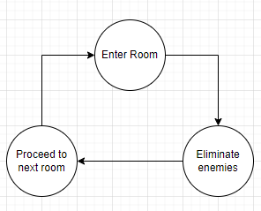
For the player to advance to the next, they must eliminate all the enemies in their current section.

Game Pillars
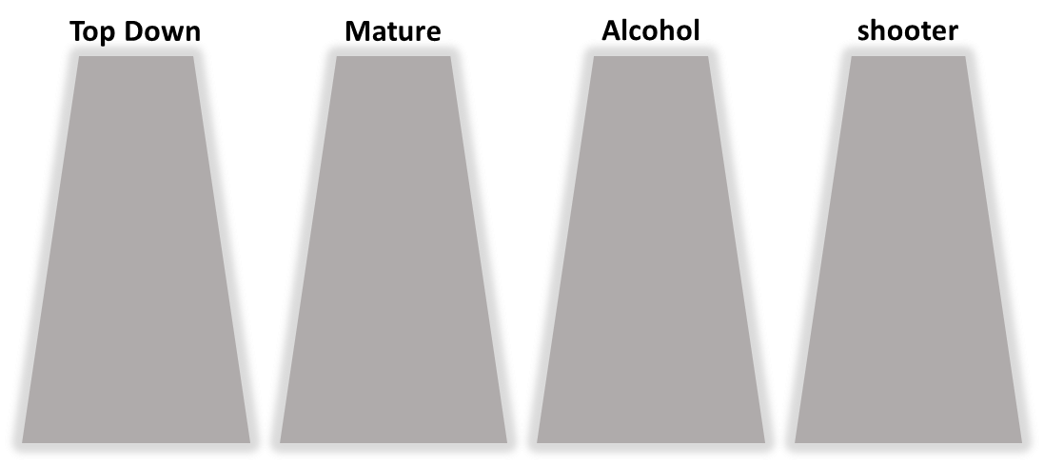

Environment
Based inside a Brewery, the level will be an expanded/exaggerated version of a brewery factory. Splitting the brewing process into 4 sections, so we can have 4 areas for the player to play in.

Genre
3D Top down Shooter.
Casual
Comedy
Twin stick shooter

Game Mechanics
Toilet cubicles will be checkpoints and will reset the players health. (SFX of the player being sick whilst they are in the cubicle.

If the player passes out, they will respawn at their last checkpoint.

UI bottle that fills up based on how drunk the player is.

USP
The environment, characters and enemies will be designed around Heineken. Because you must be over 18 to drink, the rating for this game will also be the same.

Player Characteristics Outline
The more drunk the player is, the worse their aim.
If the player gets too drunk, they pass out and lose a life. If they lose all their lives, it's game over.

Could have voice lines, the more drunk the player, the more outrageous things the player will say

Start with a default weapon, Pick up new weapons from bosses or chests.

Target Audience
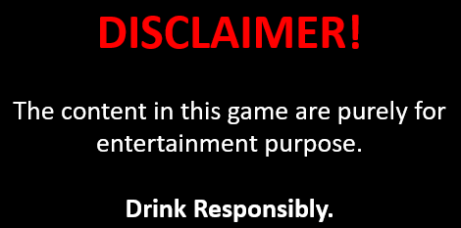
Over 18

Level Design Documentation:

Goals of level & key areas

- The objective of the game is to activate the 4 levers found in each major section of the brewery plant and to head to the processing room to open the lobby room in which the player fights their doppelganger to get the spot.
- Click here to see the level flow diagram
- Alternatively, click here to see the JPEG file of the level flow diagram

Story
The brewery has a competition to find a new mascot, you need to make it through to the final fight with the current mascot to win, but watch out, other mascots are competing too and they’re desperate to get you too drunk to carry on.

Focal Points

- Aging – Room where the barrels are stored and kept to impact the beer’s flavor.
- Silo and Sorting – Another area for the brewing process where the beer is filtered and a major area where the player activates a lever after defeating waves of enemies.
- Bottling – Where the beer is put into bottles packed in pallets. A major section where the player activates a lever after defeating waves of enemies.
- Brewing and Fermentation – Where the beer is brewed and fermented. Major section where the player activates a lever after defeating waves of enemies.

Lighting

- In Enter the Drunkgeon, the lighting will be done mostly through spot and point lights.
- While commercial lights and panels fill up the brewery, this will not be shown as the game is top-down and will rather be indicated that it is there through the lighting done in-engine.

Visual Development

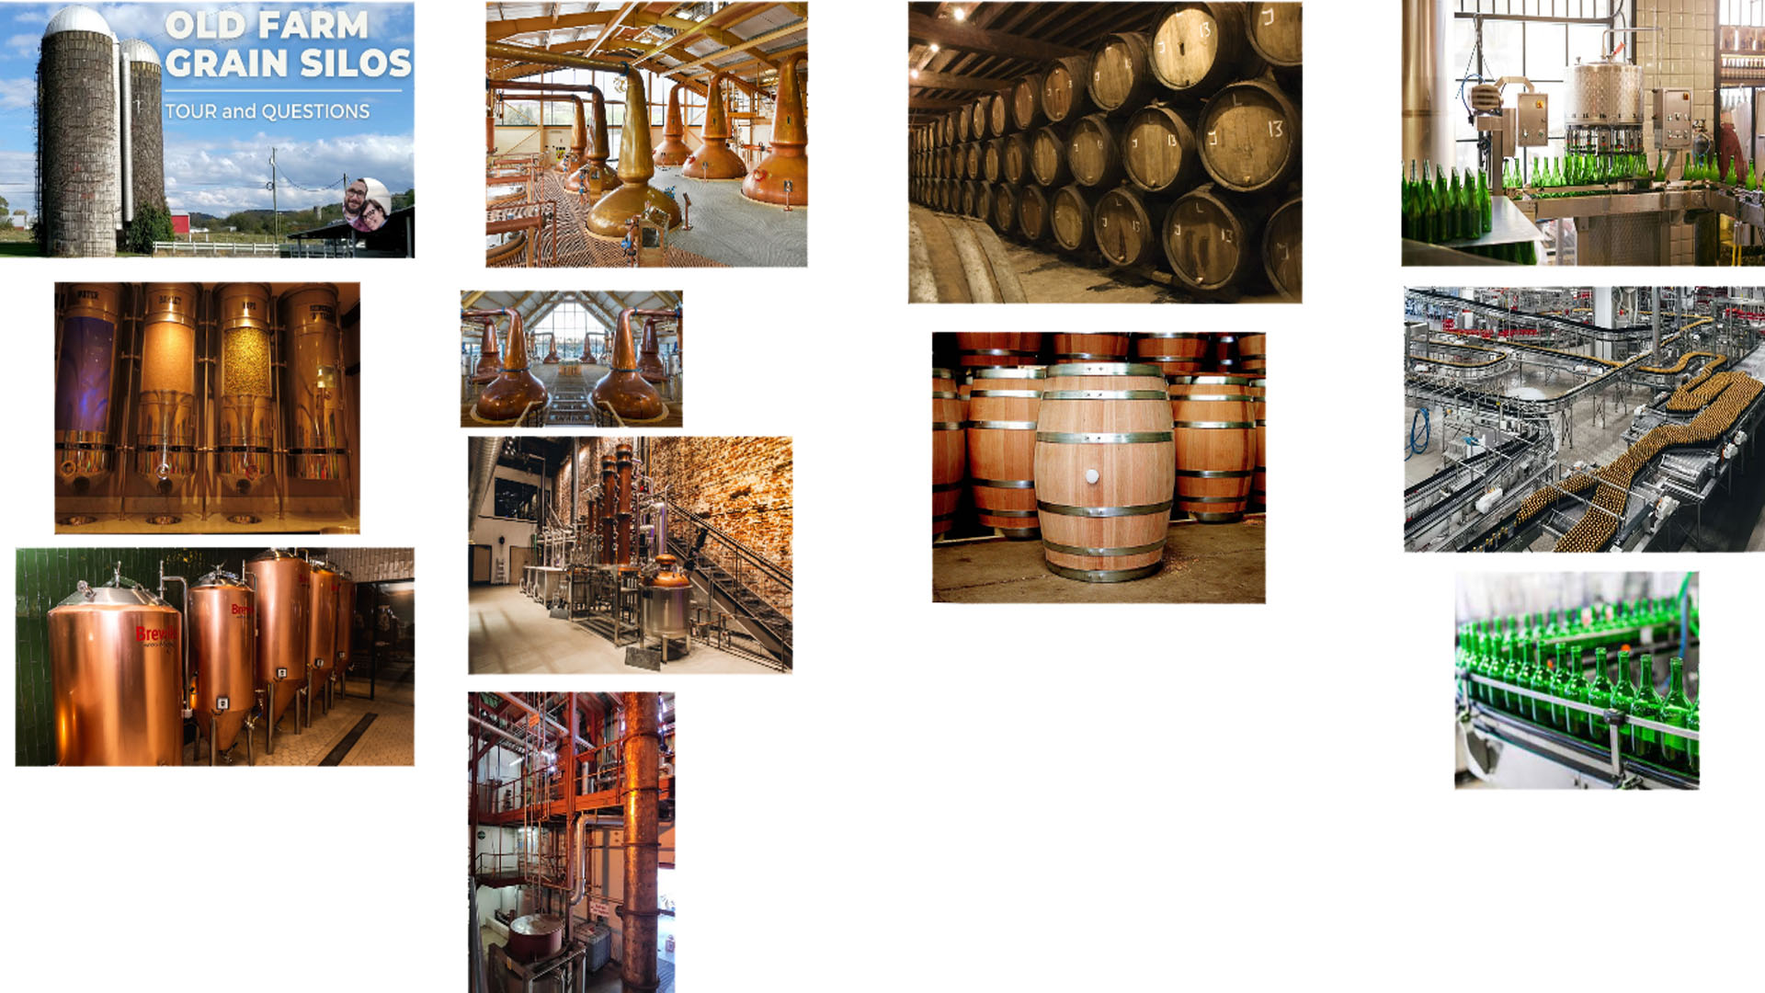
- Below you will find a moodboard of various brewery sections used as inspiration on the Heineken brewing factory.

Colour Palette

Floor


Walls

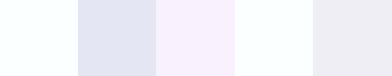
Lighting

Level Design Plan

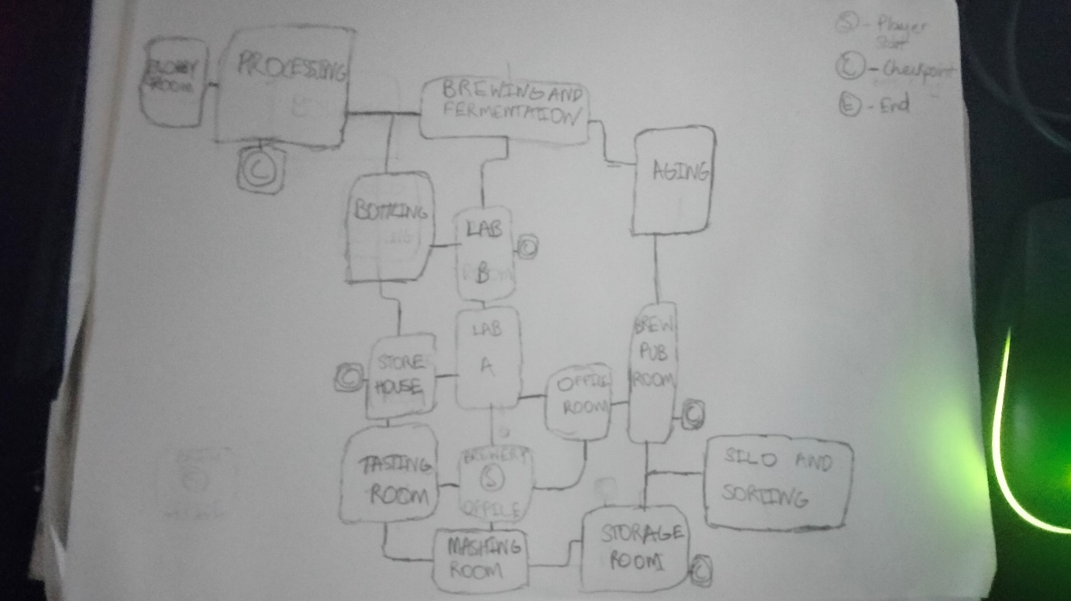
Sketch Map

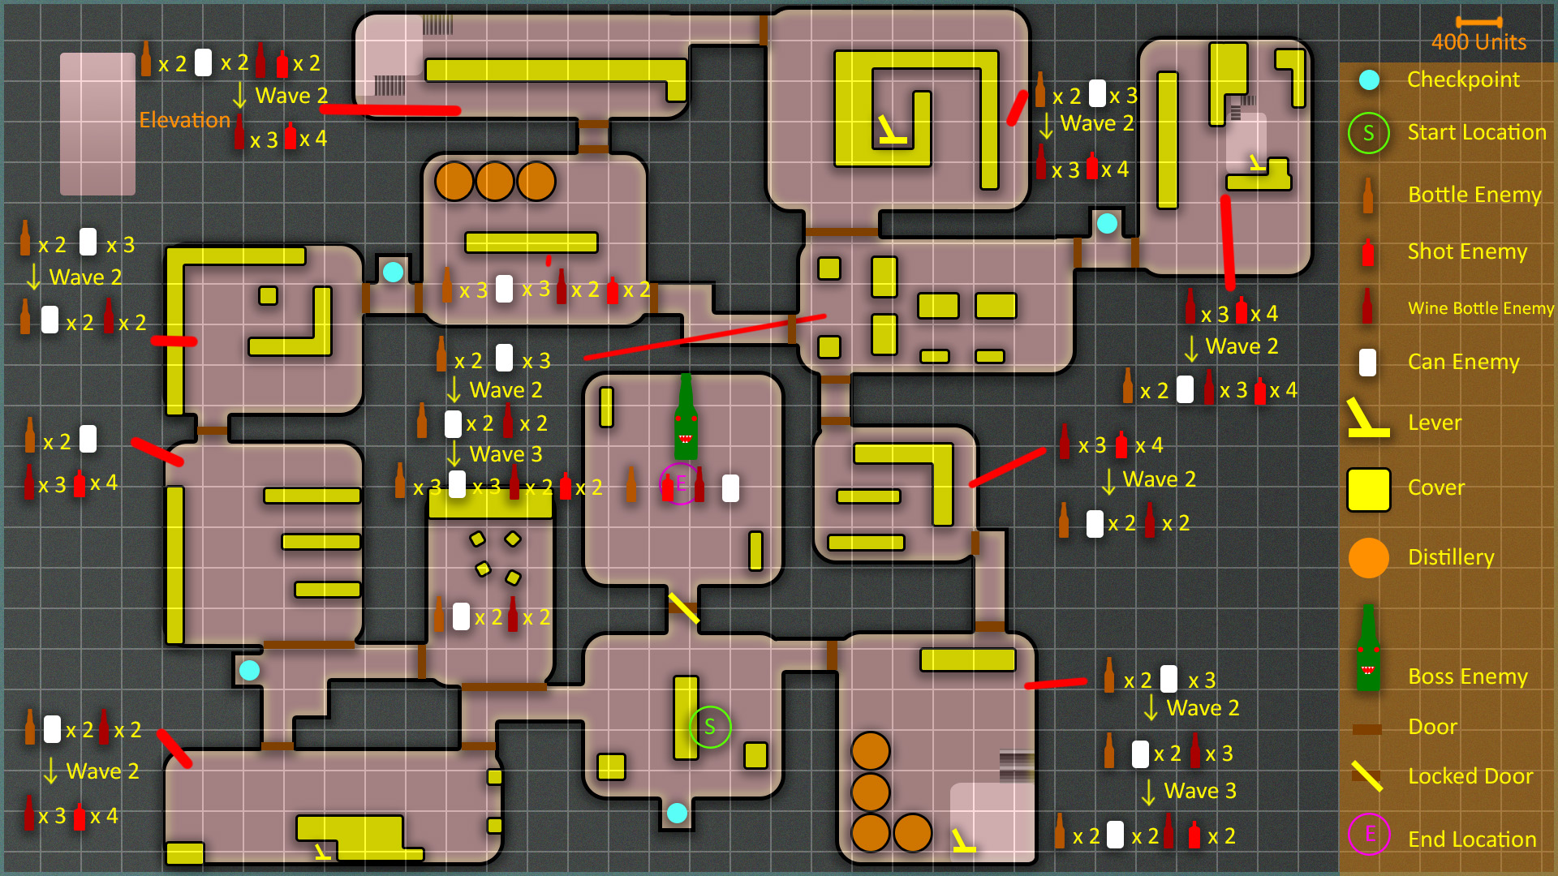
Level Design Map

Blockout
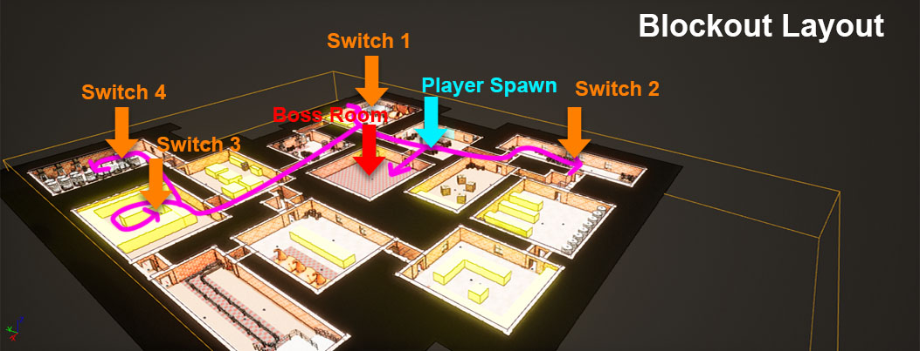

Modular Tile Set Sizing:
Floors: 400x400 units
Small floors: 200x200
Walls: Length 400, Height 250, thick 40
Half Length wall: length 200, height 250, thick 40
Half Height Walls: Length 200, Height 100, thick 40
Columns: Length 100, Height 250, Thick 100
Beams: Length 50, Height 350, Thick 50
Doorway Hole: 200 height, 140 wide, 50 thick. (Inside either a 200 length wall or 400 length wall)
Stairs: 300 wide, 100 thick, 100 height

Focal Points

- The focal points of the level focus on four different sections which is spread out throughout the entire layout of the map. However, the areas with the levers and the boss area will be the focus for high intensity combat. These areas are shaded in purple below.
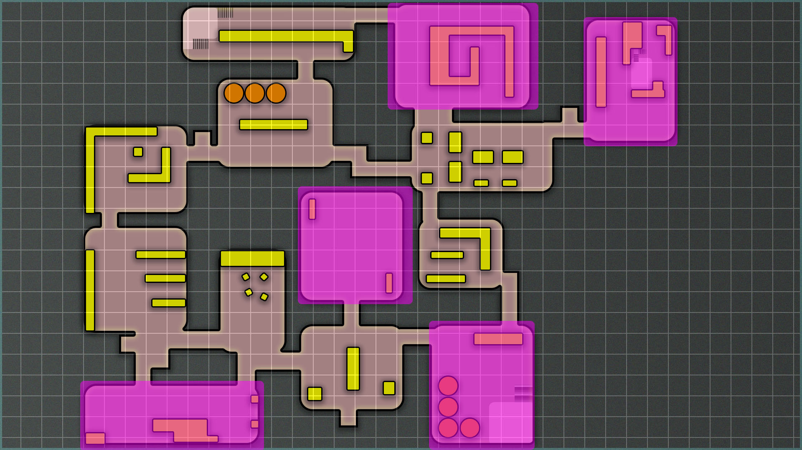

Story Element Locations

- Most of the areas have the same layout as the focal points, so the player will explore these four points throughout the map. However, the fight with the boss after the four levers have been activated will be where the player discovers the Heineken man.

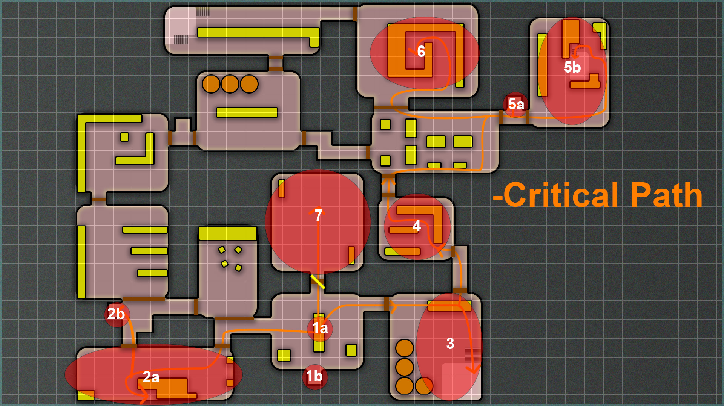
Critical Path Analysis

1a – Player spawn.
1b – First checkpoint the player finds.
2a – First lever room the player can encounter. They fight waves of enemies, collect their powerups and activate it.
2b – Second checkpoint the player can find, not too far from the spawn.
3 – Another room with a lever on an elevated spot. Wave based encounter.
4 – Room with lots of cover. Wave based encounter.
5a – Checkpoint the player can find on the way to the last two levers.
5b – Another lever room with covers around the sides and the lever on an elevated spot. Wave based encounter.
6 – Final lever room with cover all around the middle and also enclosing the lever. Wave based encounter.
7 - Boss room. Player needs to activate four switches to enter this room. They encounter the boss mascot and waves of his henchmen. Player fights them off and wins the game by defeating the boss.

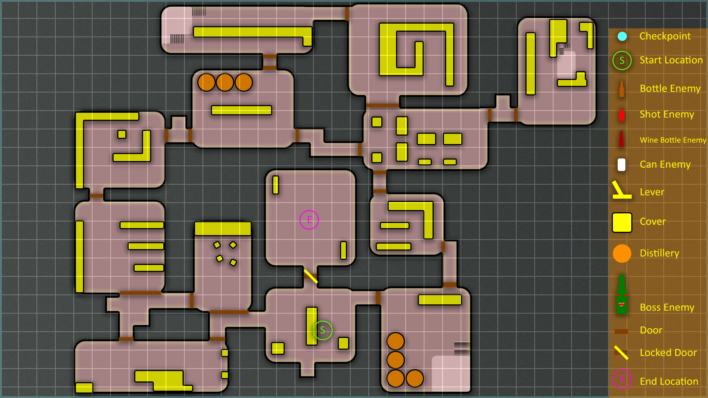
Level Start & Level End Location

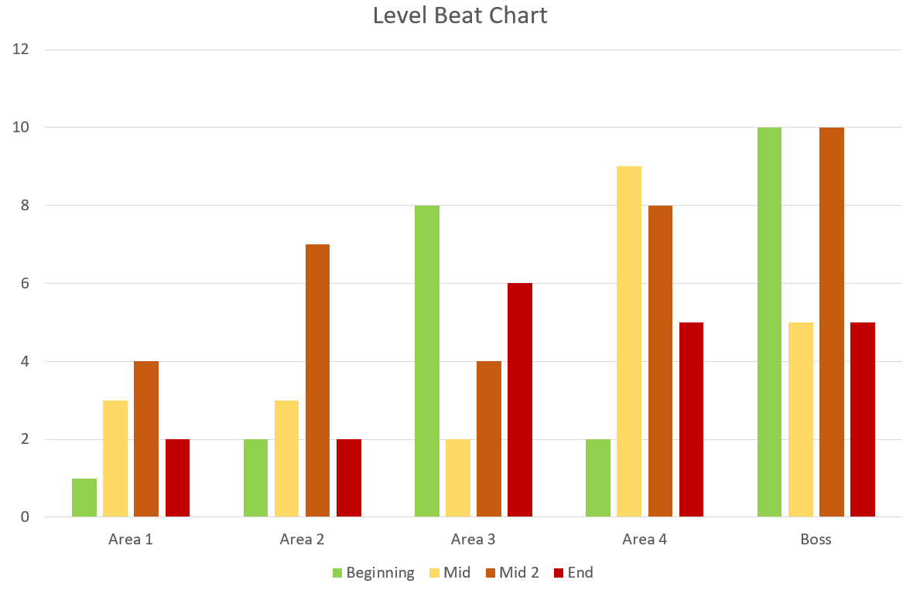
Beats and Pacing

Player Characters, Controls and Abilities

Player Controls and Map

Player Camera
The player’s camera will be top down, the camera about 1000 units away from the player in an angled position. The camera follows the player constantly based on their movement in the centre and can’t rotate.

Character/s background
The player is trying to make it to the end of the level and win the challenge of staying sober enough to eliminate the Heineken doppelganger.

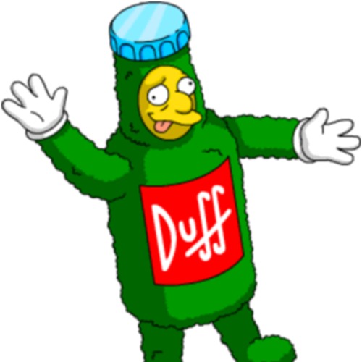

Character/s Mechanics

Mouse – Use the mouse to turn the character to face the direction you want
Drop Weapon – The player can opt to drop a weapon early before it times out.
Dodge ability – Player launched forward, invincible from attacks for that period, vfx indicating this and player can use this ability every 2 seconds
Health system – There will be a Beer Bottle that fills up depending on how drunk the player has gotten. Starting from 0, if the player reaches 100, they will pass out and respawn to the last checkpoint
Lives – 3 bottles will be visually represented as lives/attempts the player has to reach the end of the level. They will not be able to earn lives.

Weapons and Pickups

Projectile Description
The projectile will be the same, but the player can pick up power ups to improve the weapons damage or fire type.
Power ups will only last a short time, they can be found by killing enemies or opening chests.

Power ups won’t last long, if a player already has a power up active and comes across another one, it will either reset the or replace the current powerup.

Powerups will look like shiny orbs with a capital P on them. The only difference being, is the colour.

Radial pickup – Purple orb
3 Burst – Blue orb

Grenade – Red orb

Enemies have a 1 in 4 chance of dropping a powerup.

Weapon Stats

Weapon Type | Description | Damage | Duration | Visual
Default | Single fire shot in front of the player | 20 per hit | Infinite | 
Radial | An automatic weapon that fires in all directions around the player | 15 per hit | 10 seconds | 
3 Burst | Automatic firing 3 projectiles in a spread in front of the player | 20 per hit | 12 seconds | 
Grenade | Launch a grenade a distance in front of the player | 30 to every enemy in radius | 8 seconds | 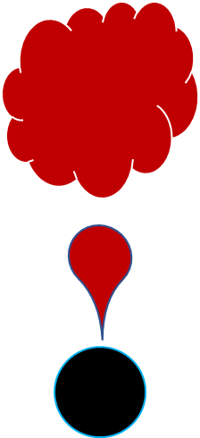

Game Conditions

How do you win?

Kill the final boss and win the brewery.

How do you lose?

Run out of lives/attempts before completing the competition.

Can you die?

Each time the player passes out and respawns to their last checkpoint, they lose a life.
3 Attempts/lives and the game is over.

Mission Flow
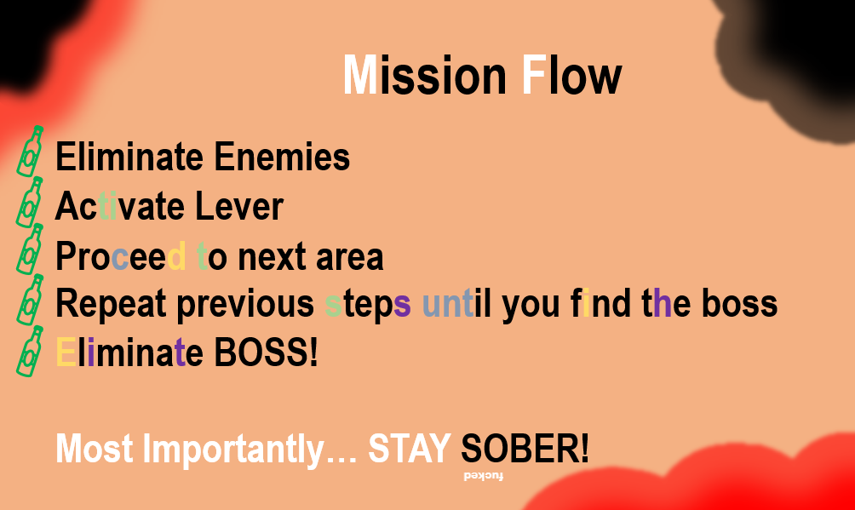

Rewards and Progress

This game will be more aimed at killers, as there is a high portion of the game that involves eliminating enemies before they eliminate you.
The big achievement will be making it to the end of the game and beating the boss to win the ‘competition’.
The collection aspect will be finding the powerups that drop and keep the player’s attack more effective.
Finally, the player will be able to explore the level, looking out for enemies blocking the path.

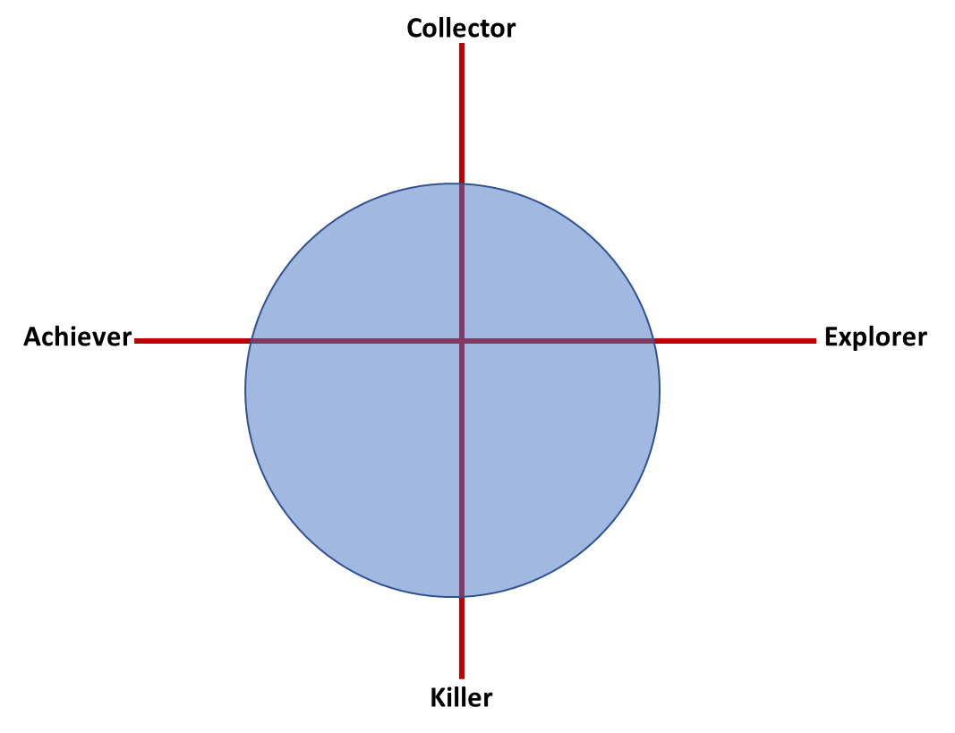

Score such as multipliers, kills, kill count, collection based.

Timer – Be the quickest to get through the level and defeat the boss.

Enemy Density

Enemies will be crowded together in specific sections of the map. They will attack together as a group, so the difficulty will depend on the size and what type of enemy is part of that group.

- Level Pacing with use of environment, enemies and pickups
Item | Description | Visual
Energy Drink | Heal 10 health every 3 seconds for 12 seconds | 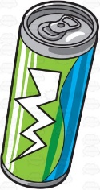  Health bar flashes each time health is gained
Burger | Heal for 30 | 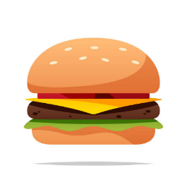
Kebab | Heal for 40 | 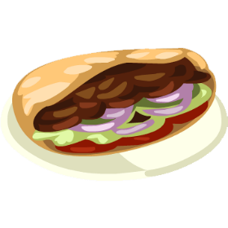
Party Glasses | All alcohol is increased by 1.5x for 10 seconds | Add glasses on the health bar UI
Steak | Lungs of Steel. Become invulnerable for 10 seconds | Add a metal material around the health bar
Cape | For every 10% of “drunkness” the players movement speed is increased by 25 (Can change) | A Cape that says “I UM De FLERSH”
Stink Bomb | Drop this and enemies avoid this cloud of stank like the plague | 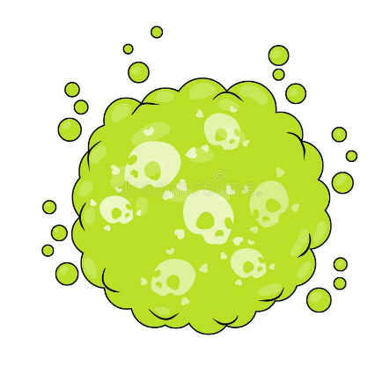
Vuvuzela | Use this to push back enemies getting too close to the player | Wind effect  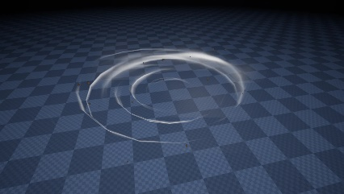

UI Design

In Game
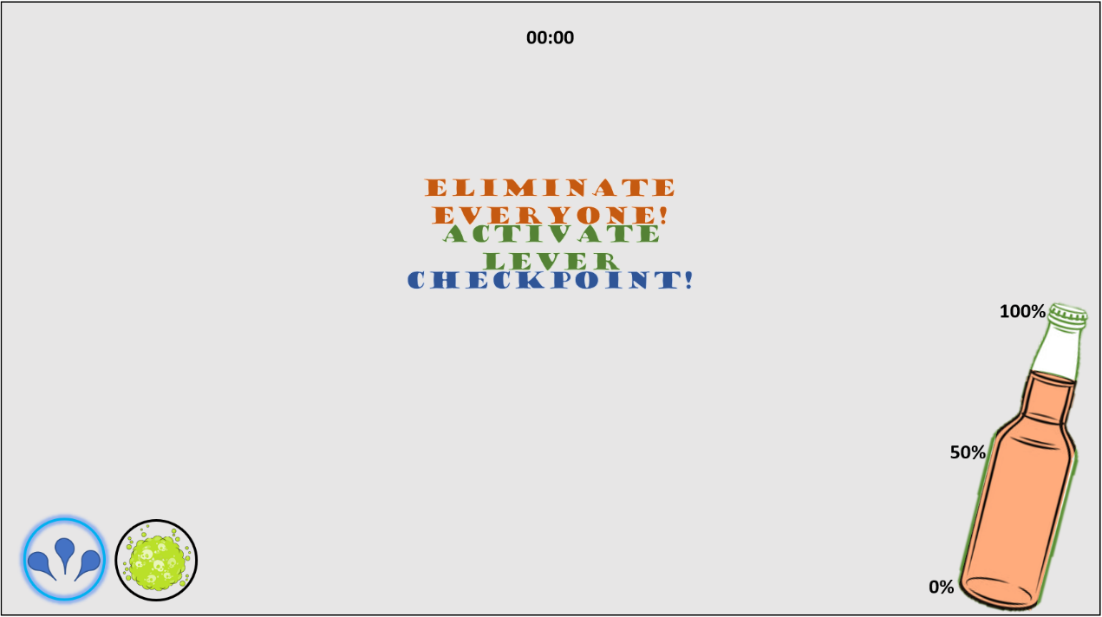

Menu
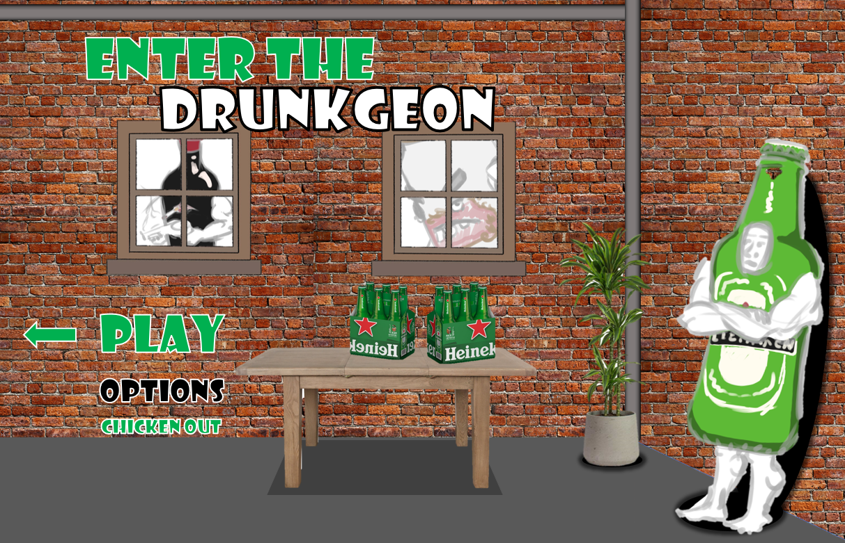

Enemy Design

Enemy Theme
Enemies will be off brand bottles of alcohol, trying to get the player drunk and eliminated.

Enemy Loop

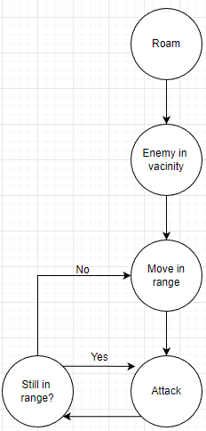

Enemy Characteristics
Enemies will attack from range. Their attacks are trying to make the player drunk.

Visually, the enemies and player will have just a costume on, so their legs and arms will be bare. The difference being that some enemies will be wearing heels so that the game isn’t dominated with Males.
Wine Bottle – As the wine bottle is tall and slim, it will be the slower enemy, but will deal more damage/drunk points to the player. Their attack will form an arc shape out of wine as if they are spilling their drink.
Beer Bottle and Stella Can – These will be the average enemies that help differentiate the other enemy types. They will fire drops of alcohol at the player they won’t do much harm but will still be a threat.
Sourz Bottle – These will be smaller enemies. Their health will be low, but their damage will be significant. They will move fast trying to get in range of the player.
Boss – The boss will be the head of the all the other enemies. He will require a lot more damage to be taken down. Take this boss down to win the competition but beware, he can see from all angles. The boss will be the only character not wearing a bottle costume. They will look like Duffman from The Simpson’s, however with the Heineken brand.
BEAT HIM TO BECOME THE NEW OFFICIAL MASCOT FOR HEINEKEN!
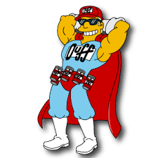

Stats

Enemy Type | Attack Type | Health | Damage | Speed (Will be based on UE5 movement settings
Beer Bottle  Stella Can | Range, Single fire | 35 | 10 drunk points per hit | Average
Wine Bottle | Range, Arc fire | 30 | 20 | Slow
Sourz bottle | Explode in radius | 10 | 25 | Fast
Boss | Circle Radius Attack | 200 | 25 | Average

Level Elements
Wet floor – Player will slip and slide making it hard to stop after letting go of a key

Burst Barrel – A Barrel will explode and will make the player drunk if they are in radius.

Moscow
Must Have
Player Inputs and interactions
Basic enemies and a boss
Power ups to change weapon
Full Game Loop
Environment Set up
Should Have
Multiple enemy types
Checkpoints
Polish
SFX
Could Have
Voice Acting
Separate game mode using a section of the same environment to make a wave-based game.
Won’t Have
Inventory system
Multiple Levels

Sound List

Character Sounds
- Player Hit (Multiple)
- Being Sick
- Run
- Passing out
- Enemy quips (Multiple)
- Shooting weapon
- Drinking

Environment Sounds
- Menu
- Main game music
- Boss Fight
- Steam

Object Sounds
- Barrel break
- Slipping on liquid
- Door slam
- Lever

Animation List

Character Anims
- Run in all directions
- Shoot
- Enemy run forwards

