Digging Through Death Prototype Treatment Document

Environment Design & Research
Taionee Rhodes

Version: 2.2
Date: 15/12/22
Contents
Game Name Treatment Document 1
Executive Summary 3
Game Overview 4
High Concept 4
Genre 4
Hooks / USP 4
License 4
Gameplay Highlights 4
Multiplayer Highlights 4
Technology Highlights 4
Audio Visual Highlights 4
Hardware required to play the game 4
Production Details 5
Project Status 5
Development Team 5
Budget 5
Scheduling 5
Competition 6
Game world 7
Back Story 7
Objectives 7
Characters 7
Story progression 7

Executive Summary
A zombie apocalypse survivor must escape an abandoned mineshaft they’ve been using as a shelter for the last few years as they’ve run out of supply, but the elevator is broken and the mine has become infested with zombies, the player must make their way to the surface as the elevator keeps breaking down, requiring them to explore to find ways of repairing it.
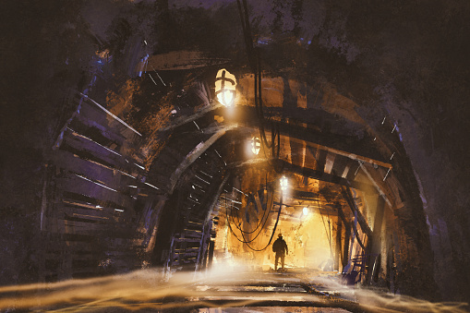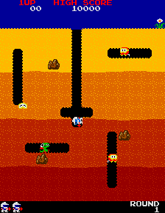
The games main theme will be post apocalyptical, with a blended realistic cartoony art style. It will focus on an apocalypse survivor trying to protect his improvised zombie shelter.
Core Loop
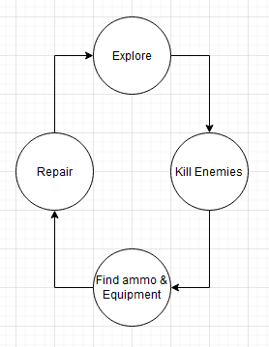
The core loop begins with the player exploring their surroundings, finding and killing enemies, finding and collecting weapon and equipment and then repairing the elevator to move to the next level and slowly escape the mine.
Gameplay Pillars
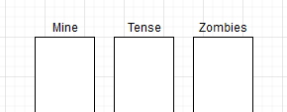
The core gameplay pillars focus on the theme, target feeling and core enemies.
Core Mechanics
The primary core mechanic will be an Eagle Vision type system for viewing enemies and collectibles around the player.

Game Overview

High Concept
An exploration game with wave based combat and light survival mechanics focused on a zombie apocalypse survivor escaping his hovel. Inspired by the 1982 game Dig Dug

Genre
First Person Shooter, Exploration, Post Apocalypse

Hooks / USP
Why players will want to play this game (may relate to technology section below)
6th Sense - The player will have a sixth sense type ability similar to Assassins Creed Eagle Vision to see enemies and level objects. This will be achieved through a custom stencil depth. This is the mechanic which sets the game apart from the competition.
Puzzles & Waves - Light puzzle mechanics for progression combined with wave-based zombie horde combat. The player will have to activate various pieces of machinery to keep the elevator functioning, as well as deal with spaced out ‘waves’ of zombies. This is a classic hook for a shooter adventure game.
Post Apocalypse - A Post apocalyptical theme focused on a zombie apocalypse. This is a hook for a portion of the market who enjoys the genre.

Gameplay Highlights
What gameplay will stand out in your game?
Killing zombies - The main gameplay mechanic for the game is killing the zombies so completing a zombie wave should stand out as a gameplay achievement. At the end of a wave the player has a chance to catch their breath and explore before progressing to the next section.
Activating the Elevator - Activating the elevator should give the player a sense of accomplishment and will have lights and sounds to help reinforce this. This will also trigger the next level, moving the player closer towards their eventual goal of escape.

Technology Highlights
What technology are you using to make your game stand out?
6th Sense - Using post process technology a player ability to highlight enemies and pickups through walls and floors. As previously stated this will be achieved through a custom stencil depth.
Versatile Level Assets - All assets will be designed with versatility in mind. All level assets will have exposed variables and Enums to make sure their easy to use and versatile for level design.

Audio Visual Highlights
What will be the most impactful areas of the game? How will your title be stunning?
Atmospheric Ending - An atmospheric ending similar to that of portal with the twist being the zombie infestation in the wider world was all but finished. The idea of the ending is to give the player a sense of peace and calm after the tenseness of the preceding levels.
Mine Elevator - The mine elevator that transports the player to each new level will have atmospheric lighting and SFX. This is to help reinforce the tense suspenseful atmosphere.

Hardware required to play the game
The game is being developed for PC only, the specifications are as follows:
Operating System: Windows 10 64-bit version 1909 revision .1350 or higher, or versions 2004 and 20H2 revision .789 or higher.
Processor: Quad-core Intel or AMD, 2.5 GHz or faster
Memory: 8 GB RAM
Graphics Card: DirectX 11 or 12 compatible graphics card

Production Details

Project Status
What have you already achieved, include a list of completed features and examples of what has been done.
Feature | Status | Week Completed | Notes
Player Movement | Complete | Week 4
Player Camera | Complete | Week 4
Player Health & Basic systems | Complete | Week 5
Player Weapons | Complete | Week 11
6th Sense | Complete | Week 10
Grenade | Complete | Week 11
Pickups System | In Progress | Week 7
Gates | Complete | Week 6
Lift | Complete | Week 6
Level Triggers | Complete | Week 6
Trigger lights | Complete | Week 6
Basic Enemy | Complete | Week 8
Enemy Spawners | Complete | Week 9
Level 1 | Complete | Week 7
Level 2 | Complete | Week 8
Level 3 | Complete | Week 10
Level 4 | Complete | Week 10
Level 5 | Complete | Week 10
Main UI | Complete | Week 10
Main Menu | Complete | Week 11
Sound Effects | Complete | Week 11
Current status Video: https://youtu.be/T2poI372-HI

Major Mechanics Breakdown
Talk about each mechanic in more detail
Weapon classes & Defaults – The weapon system works based on a class system, there is a single base weapon class, off of which stems the pistol and assault classes, which in turn parent the revolver and rapid-fire weapons respectively. The weapons then have class default settings for any variables required for the different types. For example, rapid and assault weapons have higher fire speed and can be held down to fire on automatic, whereas the pistols have higher damage and slower fire speed.

Level progression upload/download – at the beginning and end of each level all the players core stats are stored in a Struct which is kept inside the instance to make sure the players state carries over through levels. The biggest variable stored is the array of ammo types, this is an array of strings and ints. The string contains the ammo current and maximum (xx.xx) and is split to create the ammo clip variables, and the int stores the larger ammo pool for the weapon.

6th sense ability - The sixth sense ability works by applying a custom stencil depth to the player character. Every mesh that will need to be seen with the ability has a number applied to it. 0/null makes a mesh appear desaturated, 1 makes the mesh appear as normal, 2 gives the mess a red colour, 3 a gold colour and 4 a green colour. These are then used to represent the different level elements the player can see, red for enemies, green for progression elements, yellow for pickups.

Enemies - The enemies work through a behaviour tree. When the level begins the game mode finds all enemy spawns and uses these to create an enemy control that retains their spawn and uses its location to spawn an enemy. The enemy has a default wander state which has them navigate based on the nav-mesh, when the player is detected they then switch into a charge state where they attempt to get close enough to attack the player, they then switch to an attack state where they attack the player until either the player dies, the player moves out of range or the enemy dies, if the player moves away it will default back to the charge state and begin charging them again.

Development Team
This is likely to be yourself for the module work, but this is your opportunity to make your development team appeal to a backer.
All elements other than art will be completed by myself. My principle focus will be on the shooting mechanics followed by the full game loop, meaning the level progression and game completion.

Budget
How much will your game cost to develop?
Software: Free
Person hours: 143 hours over 11 weeks
External Costs: N/A

Scheduling
What are your major milestones?
- Formative Deadline: 11/11/2022
- Summative Deadline: 16/12/2022
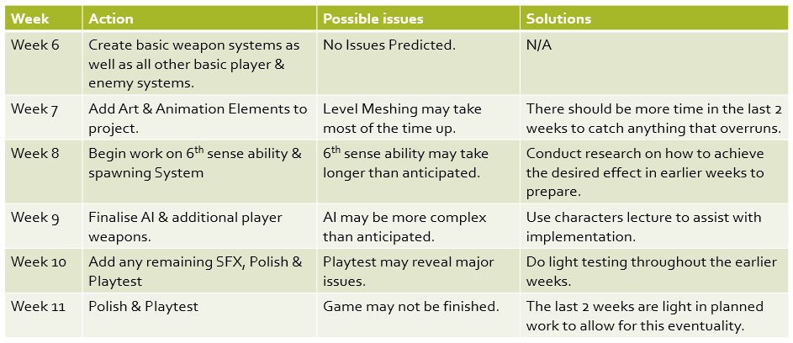
Above is the Action plan I created in week 6 documenting the plan for the following weeks, For the most part this was stuck to but as is shown in the project status table most ran over by a few weeks.

MoSCoW
Must Have | Should Have | Could Have | Won’t Have
6th Sense | Wave Spawning System | Mini Map | Multiple Enemy Types
Mining Lift | 5 Levels | Quest, Ui Help | Additional Levels
Basic Zombie | Secondary Weapons
Basic Ranged Weapon | Grenade Attack
Pickup System | Traps
Trigger System
1 Level
Digging Elements

Competition
What competitors does your game have? What other titles will be in circulation when your game releases? How are you better than the competition?
There will be a number of games available when Cave Game releases that have comparable gameplay and genres, the on the most closely resembles would be Left 4 Dead. Left 4 Dead is a Co-op zombie themed games where players must navigate through a zombie infected map to a series of safe rooms before completing the level, they can change weapons, collect ammo and heal in the safe rooms before moving on to the next through waves of zombies.
The main differences between the two being that Left 4 Dead is a co-op game where 4 player work together to complete the level and that Left 4 Dead has additional different Enemy types to further challenge the player. Cave Game tries to appeal more to the killer and explorer player architypes (Bartel. 1996) which ones again lines up with Left 4 Dead, however, in being a co-op game it also appeals to the more social player architypes who enjoy competing as a team, the game also contains achievements to appeal to the achiever architype. Despite Left 4 Dead’s more broad appeal cave game should still draw in a portion of the market which focuses more on single player games over multiplayer, keeping it competitive.
Left 4 Dead, 2008
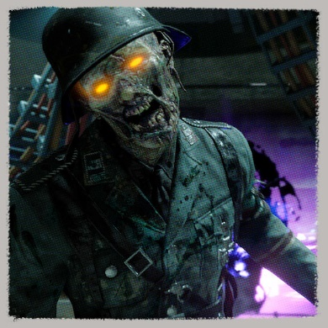
Some other more broad competitors would be the Call of Duty: Zombies(COD:Z) game mode and Tomb Rader though these focus more closely into specific areas of Bartels taxonomy.
COD:Z is an arena type shooter where the player faces endless waves of zombies, gaining money for each kill which can be used to purchase different weapons or ammo or to open new sections of the map giving access to different weapons and choke points. COD:Z appeals much more to the killer architype than anything else, it has elements to appeal to the others, for example it can be played multiplayer and single player, does contain achievements and the player is free to explore the map to find alternate weapon types or special weapons. However the core single point of the gameplay is to kill each zombie wave and see how long you can survive.
Call of Duty: Vanguard, 2021
Tomb raider is an action adventure game franchise where the player explores caves and tombs to follow the games main story, while dispatching any enemies they may find hunting them. This game appeals much more to the explorer archetype, that being a core part of its game loop, exploring caves and ruins to find clues and information to progress, once again it does appeal to the killer but the combat mechanics are less evolved, it focusing more on being an action adventure game than a third person shooter.
Rise of the Tomb Raider, 2015
As previously mentioned, Cave Game does have a much less broad appeal, however there are a number of additional mechanics which should hopefully help to give the game an edge.
The games core USP is a special ability the player can use to see through walls and detect enemies, collectibles & progressive level elements. It is loosely inspired by a similar ability in the Assassins Creed franchise though it also incorporates progression elements into the system as opposed to just enemies and collectibles. From a narrative point of view, the idea is the ability more clearly visualise the characters skill of detecting their surroundings, from spending so much time in caves they are able to hear almost everything happening in a cave weather it can be seen or not.
Other than the 6th sense ability the main less unique USP’s would be the Zombie wave combat and the post apocalyptical theme, which should appeal more to players who enjoy this genre.

Game world
The player begins at the bottom of a mineshaft in a small supply room, after collecting their gun they dispatch a zombie and enter a larger excavated room with a mining lift in the centre, they activate this and being to move up through the mines levels to escape, the second level has them in some mine tunnels, the third through some recently opened cave veins, the fourth through a semi collapsed series of mine shafts and the final level allows them to escape into the world.

Back Story
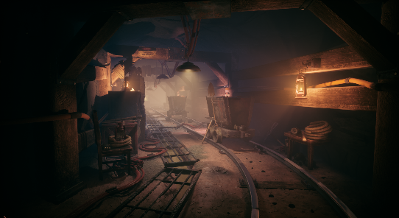
A zombie apocalypse has hit the world, the protagonist has so far survived by hiding down a mine shaft, however recently more and more zombies are beginning to appear down the mines. They’ve realised the location is no longer safe and so unfortunately must fight their way back up to the surface. Only the central mining lift is in disrepair and must be powered and supplemented in order to make it to the top of the mine.
Spending all these years down the mine has given the protagonist an almost 6th sense for the area, being able to almost sense zombies or any loot they may need through walls, hearing the tiniest noise and knowing instinctively what its from.
Unbeknownst to the protagonist the apocalypse has all but ended, with their being only a few sections of the world still infested, they have simply had the misfortune of making their home in one, so upon leaving the mine, they discover a relative paradise awaiting them.
Mineshaft – itch.io

Objectives
The players core objective is to escape the mine shaft to the surface, to achieve this they must complete smaller objectives in each level to repair the elevator, either by resupplying power to it from deactivated generators or flipped switches.

Characters
Player
The player character escaped the apocalypse by hiding down an old mine shaft, living off of the emergency supplies in a storeroom. However, they’ve begun to run out of supplies and zombies are finding their way down with increasing frequency. So, they have no choice but to fight their way back to the surface.
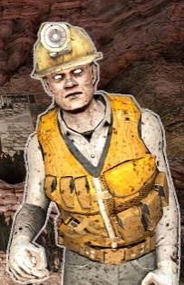
Enemies
The enemies are a mixture of zombified mine works who perished in an initial collapse or general zombies who’ve found their way down the mine.

Story progression
The story only has 3 main beats, the player is forced to leave their home, fights up through the mine and finally, escapes, realising the apocalypse is almost over and that they’re saved.
Zombie – 7 Days to Die

