Do Perception based Game Feel Elements contribute to Immersion IN Space Action-Shooter Games?
  - By Taionee Rhodes

Contents
Figure Listing 3
Acknowledgements 3
Abstract 3
Introduction 4
Research 4
Method 6
Testing 6
Evaluation 7
Conclusion 8
References 10
Bibliography 11

Figure Listing
Figure 1: Damage Reticule in Overwatch 2 5
Figure 2: Damage Reticule & Effects in Titanfall 2 5
Figure 3: Yawing to the left in Everspace 2 5
Figure 4: Table of average immersion scores with Mean & Standard Deviation. Stationary Left, Animated Right 6
Figure 5: Bar graph showing the average immersion scores out of 155 for each condition. 7
Figure 6: Bar graph showing the accuracy % for each condition. 7
Figure 7: (Left) Ship Yawing in the animated state, (Right) Ship yawing in the Stationary State 8

Acknowledgements
Thank you to the Game Testers

Abstract
The concept of Game Feel has gained increasing importance in game design due to its ability to enhance player immersion (swink, 2009) (E. Brown, 2004) (Charlene Jennett, 2008). It involves building upon a game's core mechanics to create a more engaging experience. This paper aims to investigate the impact of two specific game feel elements (animation and camera effects) on player immersion in space action shooter video games. An A/B test was conducted with two groups of playtesters to compare the level of immersion and potential changes in gameplay ability. Although the results of the primary test were inconclusive, it did produce some interesting findings on the impact game feel may have on gameplay performance that could merit further study.

Introduction
What is "immersion" in the context of video games? According to (Cheng, 2015), “immersion is actually comprised of three stages: engagement, engrossment, and total immersion,” This paper aims to explore the link between Immersion and Game Feel elements designed to increase a players perception. “Game feel enables objects external to the body to be subsumed into body image and feel like an extension of the body” (swink, 2009), This describes the ability for virtual Game Feel elements to immerse the player within the games context and convey elements of perception beyond sight & sound.
To explore this theory, two cohorts of individuals were tasked with playing two distinct iterations of a video game. While the fundamental mechanics of the game remained unchanged, one version featured a stationary player character within the viewport, while the other incorporated dynamic movement aimed at simulating the sensation of G-Force and acceleration within the game context. The aim of the experiment was to focus on the "engrossment" stage of immersion, as the prototype being tested was not complex enough to allow players to reach the level of total immersion. This limitation will be taken into account when analysing the results of the study.

Research
The ability to recalibrate one's perception and control based on the tool or object being used is a common phenomenon. For example, when holding a pen, a person naturally adjusts their hand movements and grip for writing. Similarly, when operating a car, a person adjusts their perception and control to the specific nuances of driving that particular vehicle. People become immersed within the context of the action, as within a video game. “[The player has] substituted their visual sense for one in the game world.” (swink, 2009). As games design theories & technology evolves and improves over time, so too do the ways we can work to immerse the player.
Arguably, Virtual Reality (VR) offers a highly immersive gameplay experience, such as the ability to pick up a virtual object using a real hand. Providing a medium for games to very quickly drop a player into a state of total immersion within the world “[Gamers] will have entirely lost their self-awareness as if their consciousness has transferred from reality into the game world.” (Cheng, 2015). However, this medium also comes with significant limitations, most notably in terms of movement within the virtual space. In most cases, the physical area available for VR experiences is confined, making it unlikely for users to physically walk around a space larger than a few meters. As a result, the need for in-game movement arises. This can result in a loss of immersion to the player, something non-VR experiences don’t suffer from to the same extent; the player isn’t required to switch from real world input to virtual input, the controls for interacting with the virtual world remain the same.
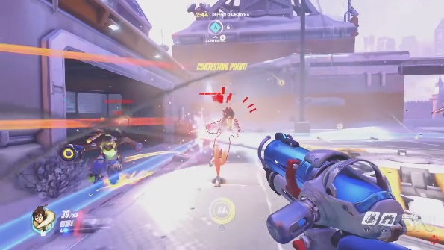
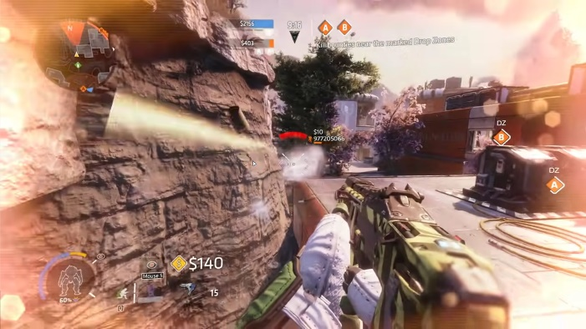
Outside of Virtual Reality there are still numerous methods to immerse players and shape their perception within more traditional gaming environments. One instance of this approach is observed in the video game Overwatch (Blizzard Entertainment, 2016) where a damage reticule is positioned at the centre of the screen (fig 1). As the player's character sustains damage, the reticule displays red sections that intensify in colour depth in proportion to the severity of the damage. Additionally, the highlighted section of the reticule rotates around the centre, indicating the direction from which the damage is incoming. For instance, if the damage originates from the front, it would be displayed at the 12 o'clock position on the reticule, while damage from behind would be indicated at the 6 o'clock position.
Another example can be found in Titanfall 2 (Electronic Arts, 2016) where a damage reticule is also positioned at the centre of the screen. However, in this game, the damage effects are taken a step further by incorporating a screen effect around the edges of the viewport to simulate the player character experiencing pain (fig 2). Moreover, the reticule itself is more dynamically animated, with visually striking animations triggered by higher damage shots. In both of the above examples the game is attempting to convey the perception of pain to the player. The player is not in any pain or discomfort but these effects serve as ways of utilising the players perception of the virtual world and ties their activities within the virtual world to the human instinct of avoiding danger, further immersing them within the experience.
Figure 1: Damage Reticule in Overwatch 2
Figure 2: Damage Reticule & Effects in Titanfall 2
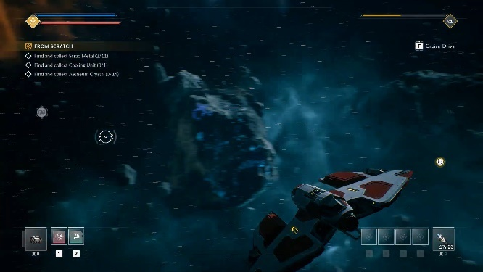
Though pain is one of the more common examples for immersing the player, especially in multiplayer shooters, Everspace 2 (ROCKFISH Games, 2020) uses a mixture of camera effects and animation to help the player perceive the G-force felt when piloting their ship. In simpler states, a camera lag is applied to create the feeling of force pushing the player back. In more advanced states, the ship moves in response to changes in rotation, such as pulling back and to the opposite side of the screen during the yaw state (fig.3) to emphasize the sensation of G-force. Particle effects are also employed, with speed lines and wind break effects created at cruise speed to convey the player's extreme speed. These elements combined seek to help the player reach a state of total immersion by clearly displaying the changes in G-force to the player, in an attempt to allow them to perceive them not only as events transpiring on the screen but forces effecting their person.
Figure 3: Yawing to the left in Everspace 2
In each of these examples, the game is using additional feedback to convey a form of perception that cannot be physically felt by the player but can be perceived to have been felt by their character within the virtual space. “Total immersion is presence. “ (E. Brown, 2004) The player will feel as though they are there, inside the game world and become cut off from their reality. These effects are intended to build upon the players sense of self within the virtual world and as such further deepen their immersion within the experience. However, these effects alone are not sufficient to create an immersive experience. “The barriers to presence are empathy and atmosphere” (E. Brown, 2004), For a player to feel present within the game world and completely immersed in the experience, they must empathize with and feel attached to the game world, as well as experience a compelling and deep game atmosphere. This research reveals that both empathy and atmosphere are created in areas of the game beyond effects, meaning that effects alone cannot create an immersive experience, despite this these elements do still contribute to the feeling of immersion.

Method
The purpose of the experiment was to investigate the correlation between game feel elements that aim to enhance player immersion and the perceived engagement of the gaming experience. Participants were randomly assigned to one of two versions of the game: one with game feel elements designed to increase immersion, and the other without such elements. After playing the game, participants completed a questionnaire that gathered quantitative data.
The Game Immersion Questionnaire (Charlene Jennett, 2008), specifically the second version utilized in Experiment 3, was selected for this study. This questionnaire was selected due to its inclusion of questions that relate to various theories of immersion, (R. Agarwal, 2000) (E. Brown, 2004) (Csikszentmihalyi, 1990), which cover concepts such as Flow, the stage of engagement above immersion, as well as in-depth theories on immersion and engagement, such as emotional involvement and autonomy. The second version of the questionnaire was specifically chosen due to its refinements from the initial version, which addressed some confusing phrasing with certain questions.

Participants
A total of 7 candidates were selected for the study, each possessing expertise in games design, The majority were other academics pursuing a master's degree, while some were external participants.

Testing
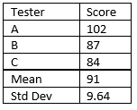
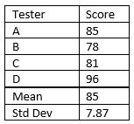
Figure 4: Table of average immersion scores with Mean & Standard Deviation. Stationary Left, Animated Right
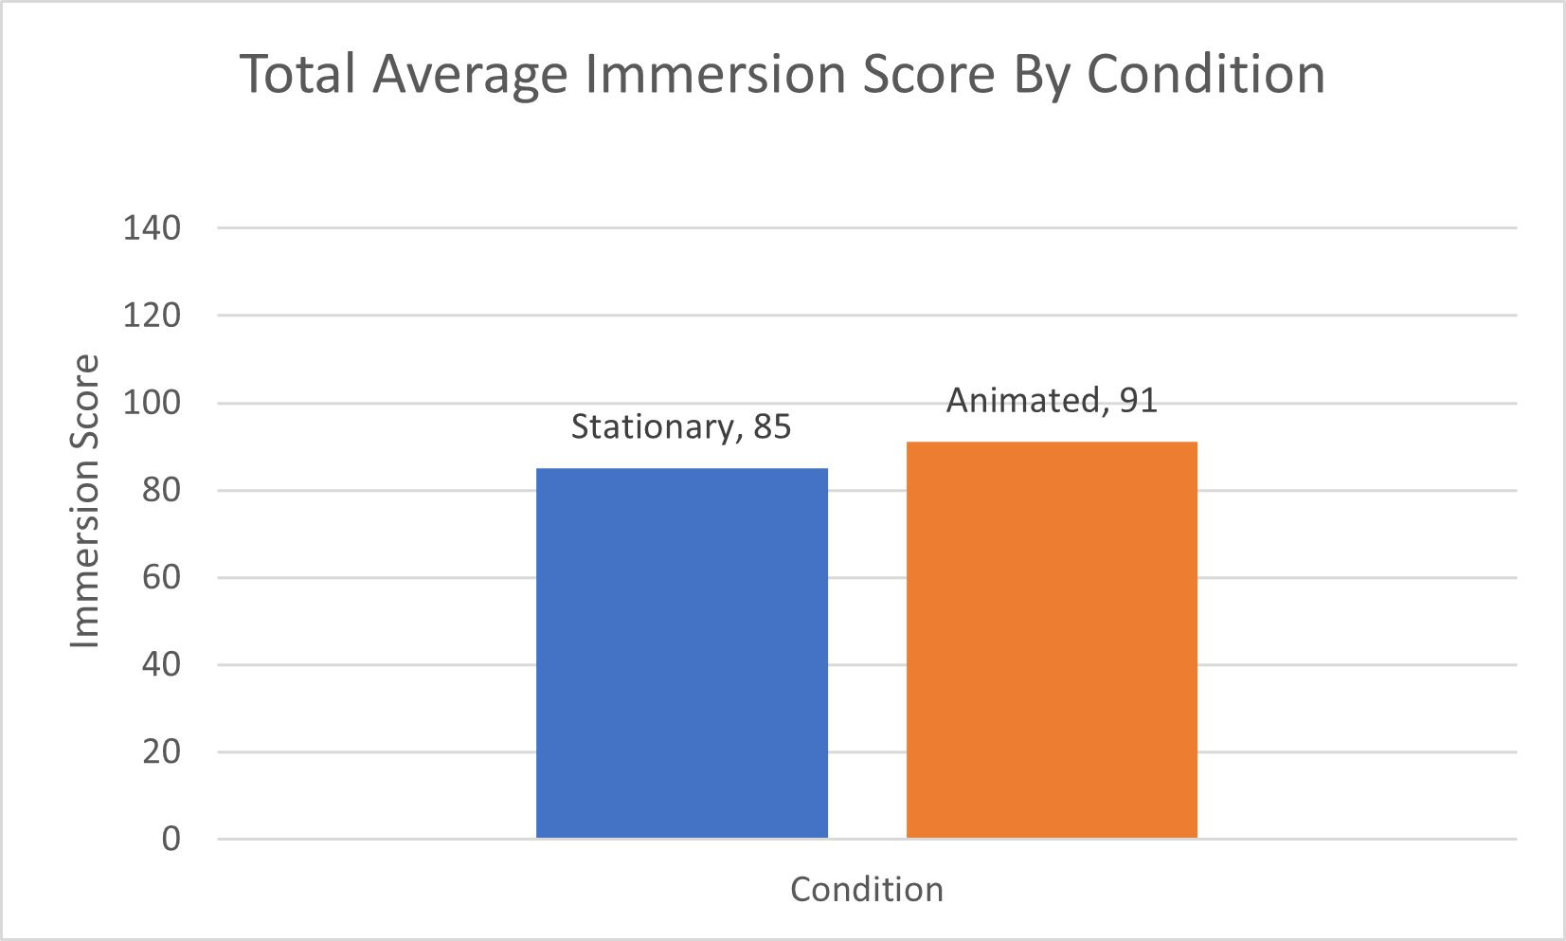
Figure 5: Bar graph showing the average immersion scores out of 155 for each condition.
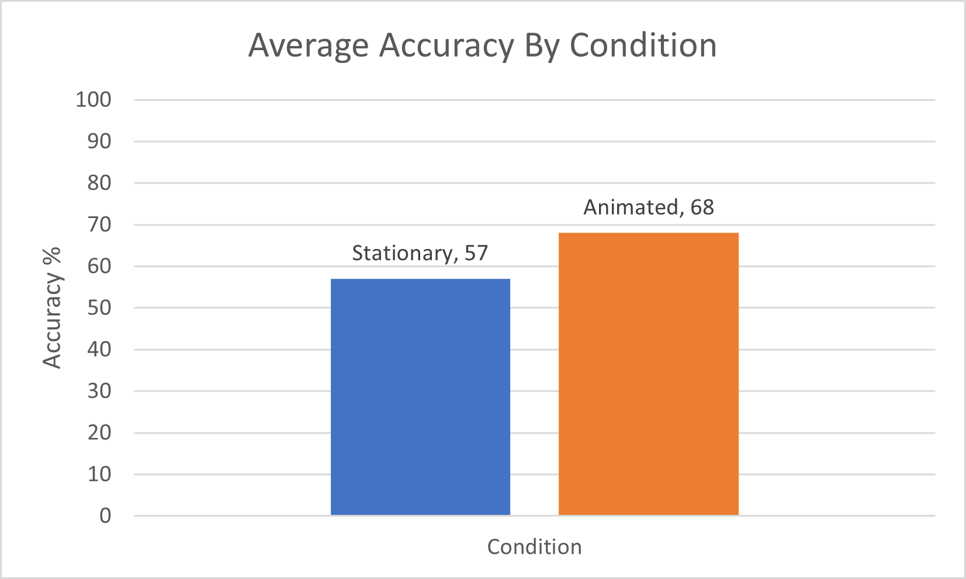
Figure 6: Bar graph showing the accuracy % for each condition.
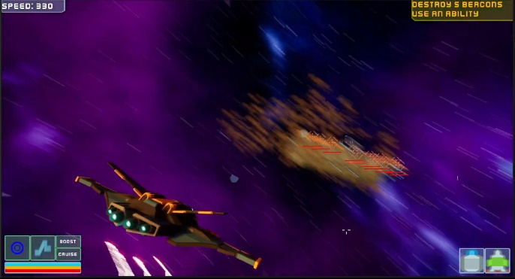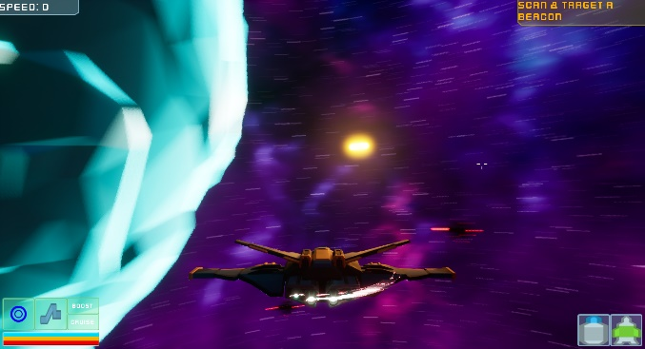
Figure 7: (Left) Ship Yawing in the animated state, (Right) Ship yawing in the Stationary State

Evaluation
Based on the conducted research, the expected results of the testing was to find that players felt more immersed in the version of the game with animation enabled, as compared to the version without. Though due to the prototypes limitations it was not expected for any tester to score above 115, 75% of the total possible score. The results did conform to this theory, showing an average increase in immersion for the players given then animated version of the game (fig.5). However, there are a number of concerns with these results.
Firstly, it should be noted that the testers involved in the university module were likely to have been exposed to the game's development process, and therefore may have been aware of the existence of the alternative version of the game prior to the testing environment. As a result, they may have had some preconceptions of what the game would look like, which could have influenced their responses to some extent.
Secondly, the sample size of the experiment was very small, with only 7 participants taking part. This raises concerns about the reliability of the data, as it may not be representative of a larger population. With a smaller sample size, there is also a higher risk of chance events affecting the results, such as one player experiencing a bug in the game that could have influenced their opinion, or external factors in their surroundings that could have prevented them from becoming fully immersed in the game.
Thirdly, due in part to the sample size, there is a very large standard deviation (fig.4). As depicted, the standard deviation is larger than the difference in the averages of the results. As a result, it can be difficult to draw any conclusive findings from the test results.

Accuracy Results
Interestingly, the Accuracy percentage increased in the Animated version of the prototype (fig.6). It was expected that the accuracy would remain the same between the two versions, due to the system remaining unchanged. The difference could be attributed to the smoother aiming mechanic in the animated version compared to the stationary version, or it could be related to the skill level of the individual participant. Regardless, this finding is interesting and merits further study.

Conclusion
Unfortunately, this paper did not find any definitive evidence to support the hypothesis that perception-based game feel elements contribute to immersion. However, this does not necessarily mean that the theory is false, as there are numerous studies and papers that support this idea, (Charlene Jennett, 2008) (Cheng, 2015) (swink, 2009) etc. The limited sample size and prototype testing limitations likely contributed to the inconclusive results of this study.
It is possible to expand upon this research by utilizing a more refined prototype and increasing the sample size. The methodology could remain the same, but a more complete version of the prototype would minimize the impact of smaller issues that may have affected this experiment. This would result in a more representative and reliable set of results. An interesting alternate take on the experiment would be too instead focus on gathering qualitative data to further understand each players experience.
Furthermore, it would be beneficial to conduct additional research into the change in accuracy that appeared to occur between the two versions of the game, specifically analysing the reasons behind this change. It could be valuable to investigate whether the difference in accuracy was due to the mechanic working better in one version over the other, due to the second version feeling more complete than the first or simply due to the skill level of the participants.
In conclusion, this paper has limited impact on the subject of game feel and immersion. However, the testing methodology appears to be sound and could be replicated with a more complete game and a larger sample size to generate more accurate results. Moreover, the results of this study suggest that game feel may contribute to player experience in additional ways, such as improving players' skill level. Therefore, further research on this topic could be beneficial to gain a better understanding of the relationship between game feel and gameplay performance.

References
Blizzard Entertainment. (2016). Overwatch. Blizzard Entertainment.
Casali, J. G. (1986). Vehicular simulation-induced sickness, Volume 1: An Overview. Orlando, FL.
Charlene Jennett, A. L. (2008). Measuring and defining the experience of immersion in games. International Journal of Human-Computer Studies, 641-661.
Cheng, M. S. (2015). Game immersion experience: its hierarchical structure and impact on game‐based science learning. Journal of Computer Assisted Learning, 232-253.
Csikszentmihalyi, M. (1990). Flow. The Psychology of Optimal Experience. New York.
Dhule, M. (2022). Creating Fun Gameplay. In Exploring Game Mechanics: Principles and Techniques to Make Fun (pp. pp. 37-68). Berkeley: CA: Apress.
E. Brown, P. C. (2004). A grounded investigation of game immersion. ACM Press, 1279–1300.
Electronic Arts. (2016). Titanfall 2. Electronic Arts.
Koster, R. (2014). A Theory of fun for games design (2nd ed.).
R. Agarwal, E. K. (2000). Time flies when you’re having fun: cognitive Absorption and beliefs about information technology usage. MIS Quarterly, 665-694.
ROCKFISH Games. (2020). Everspace 2. ROCKFISH Games.
swink, s. (2009). Game feel a game designer’s guide to virtual sensation. Amsterdam: Morgan Kaufmann.

Bibliography
Blizzard Entertainment. (2016). Overwatch. Blizzard Entertainment.
Casali, J. G. (1986). Vehicular simulation-induced sickness, Volume 1: An Overview. Orlando, FL.
Charlene Jennett, A. L. (2008). Measuring and defining the experience of immersion in games. International Journal of Human-Computer Studies, 641-661.
Cheng, M. S. (2015). Game immersion experience: its hierarchical structure and impact on game‐based science learning. Journal of Computer Assisted Learning, 232-253.
Csikszentmihalyi, M. (1990). Flow. The Psychology of Optimal Experience. New York.
Dhule, M. (2022). Creating Fun Gameplay. In Exploring Game Mechanics: Principles and Techniques to Make Fun (pp. pp. 37-68). Berkeley: CA: Apress.
E. Brown, P. C. (2004). A grounded investigation of game immersion. ACM Press, 1279–1300.
Electronic Arts. (2016). Titanfall 2. Electronic Arts.
Koster, R. (2014). A Theory of fun for games design (2nd ed.).
R. Agarwal, E. K. (2000). Time flies when you’re having fun: cognitive Absorption and beliefs about information technology usage. MIS Quarterly, 665-694.
ROCKFISH Games. (2020). Everspace 2. ROCKFISH Games.
swink, s. (2009). Game feel a game designer’s guide to virtual sensation. Amsterdam: Morgan Kaufmann.

