Arcane: Weapon System Guide (v1.0)
A guide on how to set up, use and expand upon the weapon system created for Arcane Annihilation.

Contents
The System 3
Overview 3
Pre Reading 3
Data Assets 3
Data Asset Hierarchy Diagram 3
Data Asset Breakdown 3
Weapon Actor 4
Weapon Component 5
Firing Logic 5
Weapon Pickup & Chest 5
Menu Chest 6
Data Assets 7
Variables 7
Parent Data 7
Attachments Only 7
Weapon Data 7
Barrel Data 8
Clip Data 8
Stock Data 8
Weapon Actor 9
Weapon Component 10
Weapon Pickup & Chest 11

The System

Overview
This is a Data Asset driven system to create randomised modular weapons for use in Arcane Annihilation (Arcane). Weapons are broken down into 4 core components, Base, Barrel, Clip & Stock, each being responsible for setting different variables within the full weapon as well as applying a distinct mesh or material to the corresponding gun part. This system is set up to be infinitely expandable with the main limitation being meshes, materials & creativity.

Pre Reading
https://borderlands.fandom.com/wiki/Weapons

Data Assets
The data assets are broken down into types, Base weapon data, Weapon Barrel, Weapon Clip & Weapon Stock.
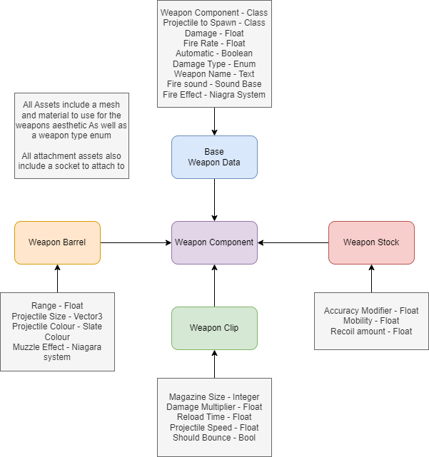
Each section of the weapon stores unique variables to help randomise each weapon. This is explained further in the data asset section. In Overview. The base weapon data component contains the core weapon variables and logic, all attachments contain supplementary variables that will assist in adding uniqueness to every weapon configuration. These are all brought together into the weapon component which is in essence, the weapon. Each data asset also stores variables for the mesh and material to use for their respective parts of the weapon.

Weapon Actor
As a designer, you should not have the necessity to directly modify the Weapon Actor itself. It should be added to the player character and initialized within the character's initialization process. However, beyond that point, there should be no further need for manual intervention.

Weapon Component
The weapon component contains all the logic for firing the weapons, it is set up in such a way that all actual logic is stored in the base class, and a child must simply assemble a functional firing chain from the logic functions.
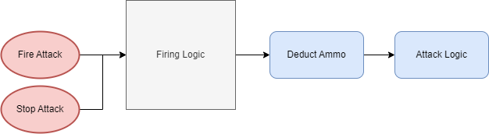
As a designer you would simply create a new child weapon component, add in the required events and parent logic, select a firing logic macro, add optional additional logic, deduct ammo, then implemented the chosen attack logic. New attack logic or option additions can be created as required in the base class.

Firing Logic
The firing logic Is stored in a blueprint macro library. The macros can be created in any of the components but must have the required events and variables plugged in for them to function correctly.

Weapon Pickup & Chest
In the final version of the game, weapon pickups can only be obtained from the end-of-round chest. However, they are equipped with logic to handle situations where they are placed in the game world, which allows for bug testing of weapon mechanics. If no specific data asset set is manually chosen, the pickup will generate a random weapon from the data asset folders and assign it to its own weapon actor. Additionally, it will create a UI display showing the weapon's statistics when the player is in close enough proximity to interact with it.
The chest is activated through the wave manager at the end of a round. The player will have to select a weapon form the chest, at which point the wave manager will begin a new round.

Menu Chest
There is also a menu version of the chest for the firing range, this will spawn a new weapon any time one is selected by the player to allow them to keep trying out different weapons.

Data Assets
This section covers the functionality of data assets and explains what each variables corresponds to.

Data Asset Hierarchy
The weapon data assets are slightly hierarchical due to the attachments sharing some variables.
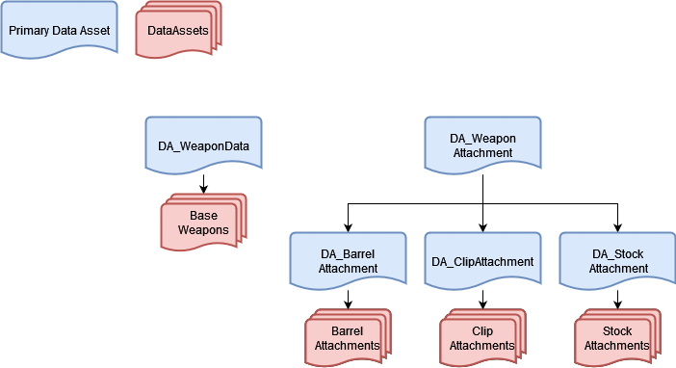
The DA_WeaponAttachment, Primary Data Asset will never be used to create a Data Asset, it only exists to store some overarching variables used within the child attachment assets. As a designer you will only be using the Weapon Data and 3 Attachment data type assets to populate the weapon system.

Variables
The Variables within the Data assets are split into 5 Categories:
Logic - The weapons firing logic.
Setup - Setup for the meshes and fire point.
Art - Aesthetic changes.
Variables - Weapon effecting variables.
Player Variables - Player effecting variables.

Parent Data
Mesh - Dictates the mesh to use.
Material - Dictates the material to use on the mesh.
Weapon Type - An Enum to group weapon components together.
Weapon components that would only work when used with a certain main body mesh type should be set to that weapon type, along with ensuring the main body is set to that type.

Attachments Only
Socket Name - The socket to connect this attachment to.
Each component will have this set in their base asset meaning it won’t need to be changed.

Weapon Data
Weapon Component Class - Firing Logic component to use.
Projectile to Spawn - The projectile to spawn, only used with projectile weapons.
Damage - damage dealt by each hit.
Fire Rate - How long between shots in seconds.
Automatic - A bool to dictate whether the weapon should fie automatically or only once.
Damage Type - The type of damage to apply.
Weapon Name - The random name of the weapon.
Fire Sound - The Sound to play when the weapon is fired.
Fire Effect - The Niagara system to spawn when the weapon is fired, only used with trace weapons.

Barrel Data
Range - The weapons maximum range.
Projectile Size - The size of the projectile to spawn, only used with projectile weapons.
Projectile Colour - The colour of the projectile/Niagara System.
Muzzle Effect - The Niagara system to spawn when firing the weapon.

Clip Data
Magazine Size - Size of the weapon clip.
Damage Multiplier - Amount to multiply the damage by.
Reload Time - Time it takes to reload in seconds.
Projectile speed - The speed of the projectile being fired, only used with projectile weapons.
Should Bounce - Whether the projectile should bounce, only used with projectile weapons.

Stock Data
Mobility - [TBC]
Accuracy Modifier – The half amount to modify the accuracy by.
The fired projectile/trace will have an offset of up to this amount in every direction.
Recoil amount – The amount to launch the player backwards by when firing.

Creating A Data Asset
To create a data asset, you would first need to decide what you’re making, a Base weapon data asset is used for the core weapon logic and variables, where as attachments store the less vital variables.

Naming Convention
Below you will find the naming conventions for the Base & Attachment assets.

Base
DA_{ComponentType}Weapon(Number as required)
Component Type: Projectile, Trace, Multi Trace, Multi Sphere Trace, Burst(addition)

Attachment
DA_{TypeInitial}_{WeaponType}(Number as required)
Type Initials: B - Barrel, C - Clip, S - Stock
Weapon Class: Assault, Shot, Long, Undefined

Weapon Type
Every weapon & attachment will have a weapon class, when the weapon is being assembled it will ensure that all selected asset will either have matching types or the undefined type for assets that can be used with any gun type.

Base Weapon
Below is an example Data asset for the base weapon.
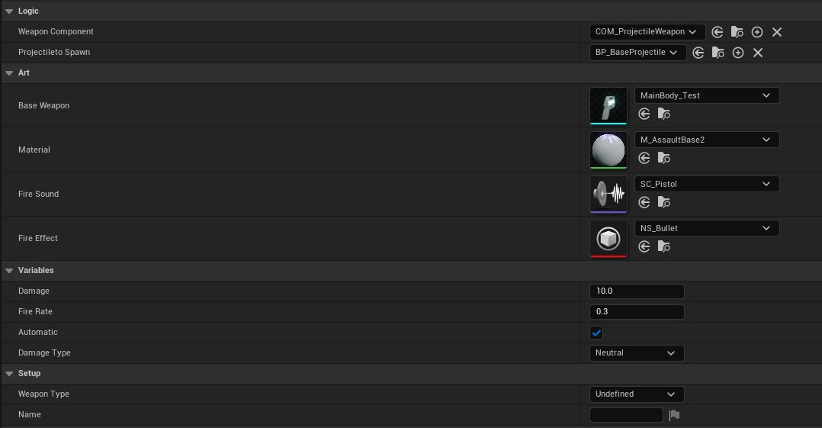
The base weapon data asset encompasses the firing logic, fundamental aesthetic elements such as the firing sound effect, and the essential weapon variables. Several of these variables can be configured using drop-down menus, while others require manual adjustment based on the designer's discretion.

Attachment
Below are examples of data assets for each attachment. These data assets require more extensive manual input compared to the base asset. However, by incorporating unique characteristics for each attachment, they will combine to create distinctly varied weapons.

Barrel
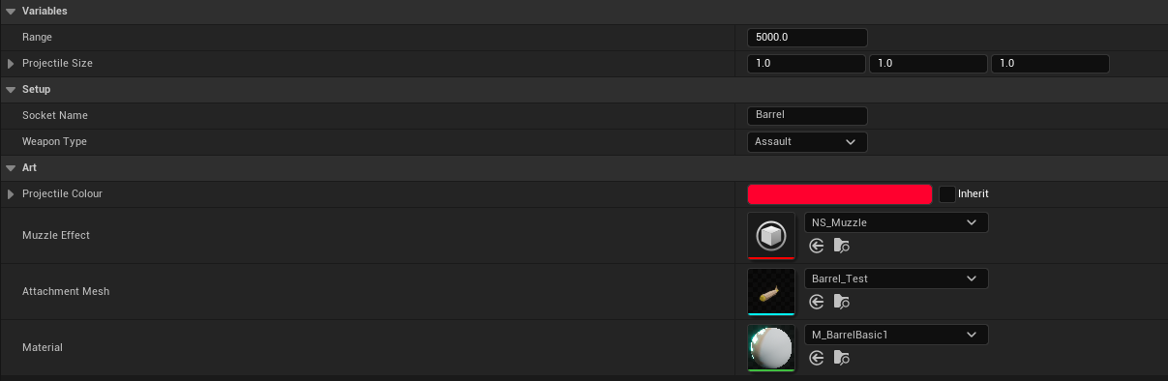

Clip
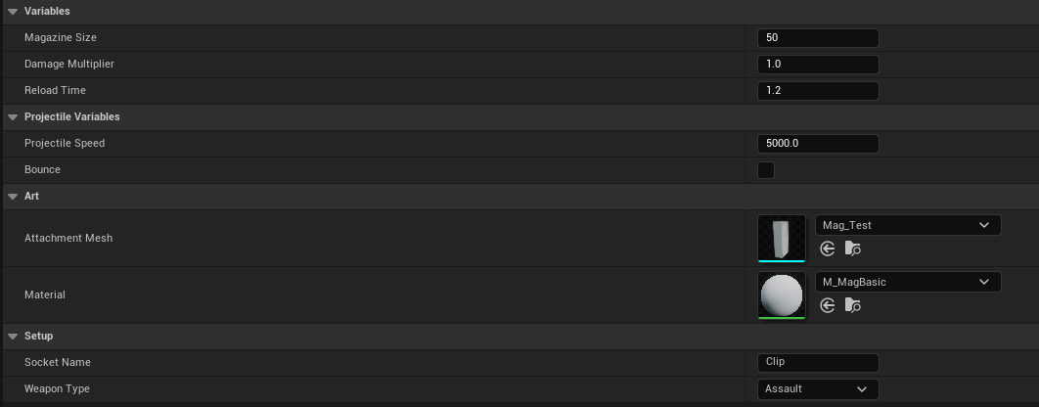

Stock
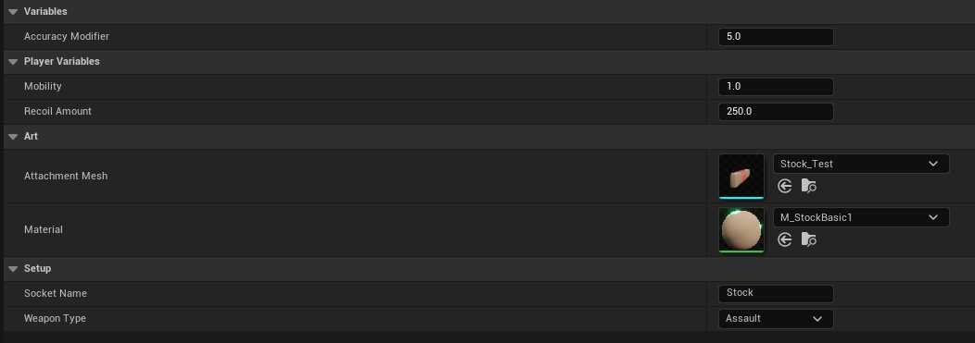

Expanding the system
This system is highly adaptable and can be expanded as necessary. Expansion options include creating new data assets to populate the existing variables, or, if desired, introducing additional variables with enhanced functionality to be incorporated within the weapon actor and component.

Weapon Actor
The Weapon actor acts as a manager for the weapon system. It is applied to the player as a child actor through which all inputs are passed to the relevant component which stores the firing logic.
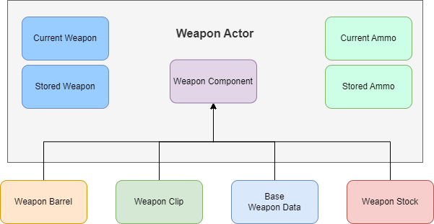
When the player chooses a new weapon, the Weapon actor will remove the previous component, create a new one, and configure all the relevant variables within it. Additionally, it is responsible for handling weapon swapping when a new weapon is acquired, as well as storing the unused weapon for the player to switch back to.
Any universal management functions should be created within this actor and subsequently applied to its component.

Weapon Component
The weapon component stores all of the core logic for the weapons. It has been set up in such a way as to be modular and expandable, working via a parent child system.

Base Weapon Component
As previously mentioned, the majority of the logic for the weapon system is contained within the base class. The weapon actor is responsible for creating and initializing the base class, while player inputs are directed through the player character into the current weapon component.
It is important to note that the base component is not useable within a data asset as it does not function as a complete weapon. Instead, it is designed to showcase the various optional logic modules available, aiding in the setup of child components.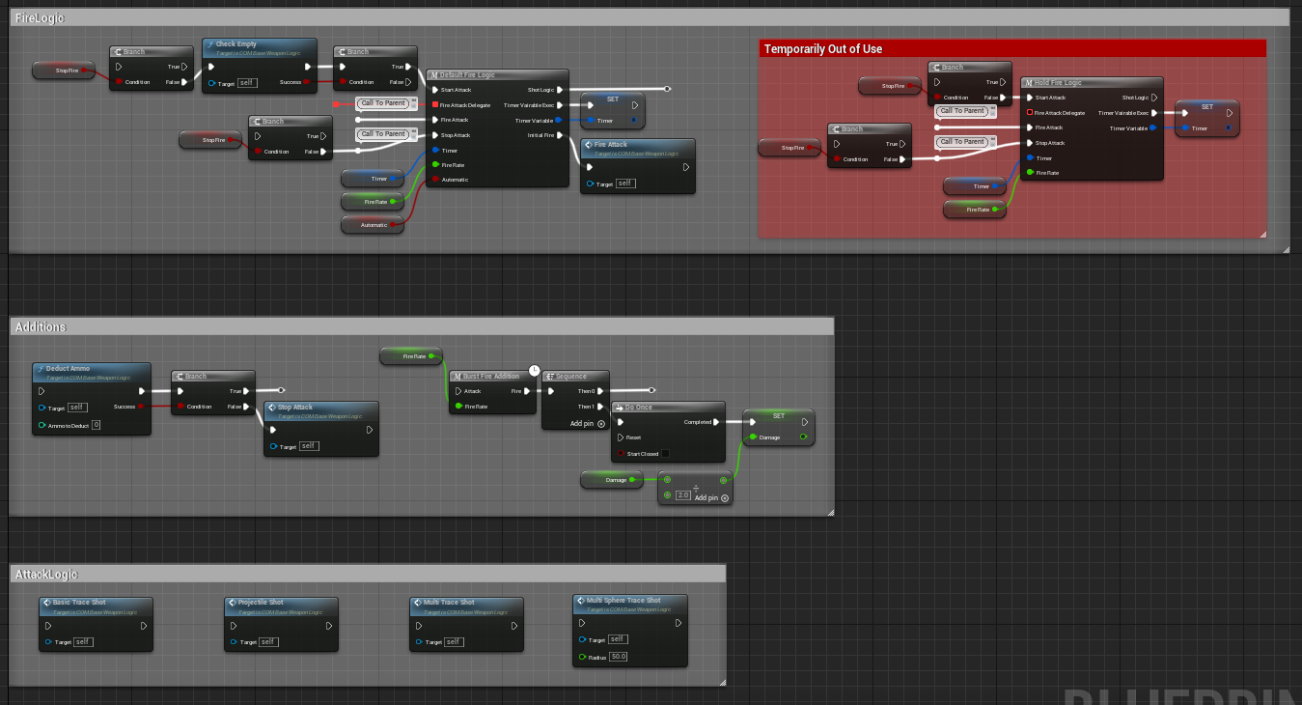

Parent Logic
To ensure proper functionality of the weapon, three events need to be implemented: StartAttack, FireAttack, and StopAttack. For the latter two events, a call to the parent event must also be implemented.
The parent event contains logic for the time dilation mechanic and prevents the weapon's fire rate from being bypassed by rapid firing. Additionally, a branch needs to be set up for the StopAttack event, as illustrated in an example below.
Additionally, certain logic must be implemented within the StartAttack event that couldn't be created in the parent event. This logic, again illustrated below, serves to prevent the circumvention of the fire rate and ensures the auto-reload mechanic functions correctly.

Blueprint Macro Library
The fire logic for the weapon is stored in a blueprint macro library, This allows for it to be implemented in any of the weapon classes. It has been created in such a way as to keep the logic simple to implement. However, this does mean a number of variables will need providing to and setting from the macro. To help with this the fire logic has been laid out in the base class allowing you to simply copy and paste it into your weapon.

Optional Additions
Any optional additions will also be created in the Macro library, though at the time of writing this only includes the burst fire addition.

Function Logic
All core logic is stored within the base class inside functions. There are a number of function classes However the core classes are Attack logic, Pre Logic & Post Logic.

Pre Logic
The pre logic is very important as it sets up some variables for the attack logic, It also handles the player recoil effect.

Range Check
The pre-logic Range check function is crucial for ensuring the proper function of the weapons. It performs a line trace down the camera to check for any objects that can be hit under the crosshair. Based on the result, it determines the target point for the weapon.
If an object is hit, the function uses that hit point as the target point. However, if no object is hit, it utilizes the trace end point as the target point. This logic is essential to prevent the weapon from potentially missing objects directly in front of the player.

Expanding the system
This system can be further expanded by adding functions to the umbrella pre logic function

Post Logic
The post fire logic handles elements such as camera shake, SFX & Animation, it is set up in such a way as to allow for additional functions to be added to it.

Expanding the system
This system can be further expanded by adding functions to the umbrella post logic function

Attack Logic
These functions contain the actual Logic for what happens when the weapon goes off. The default 4 are Projectile, LineTrace, MultiLineTrace & MultiSphereTrace.

Expanding the system
This system has been designed to be easily expandable. To implement a new attack function, after creating your attack logic you would just need to ensure these steps have been followed.
Firstly, the pre-fire logic function should be called right away within the attack function to ensure the correct setting of required variables.
Secondly, the effects section should be implemented immediately after the attack logic. This allows for the inclusion of visual effects like muzzle flash or traces.
Lastly, the post-fire logic should be implemented right after the damage node or on the "complete" pin if there is a loop. This section handles any necessary actions or logic after the attack, such as handling damage outcomes.
Beyond these essential components, you can implement any additional attack logic you desire, whether it involves a box trace or a more complex projectile firing system. The system provides the flexibility to accommodate various attack mechanisms and can be expanded upon according to your specific requirements.

Child Weapon Components
Below is an example Child Weapon, this doesn’t contain any additions and just the basic elements needed to create a functioning weapon component.
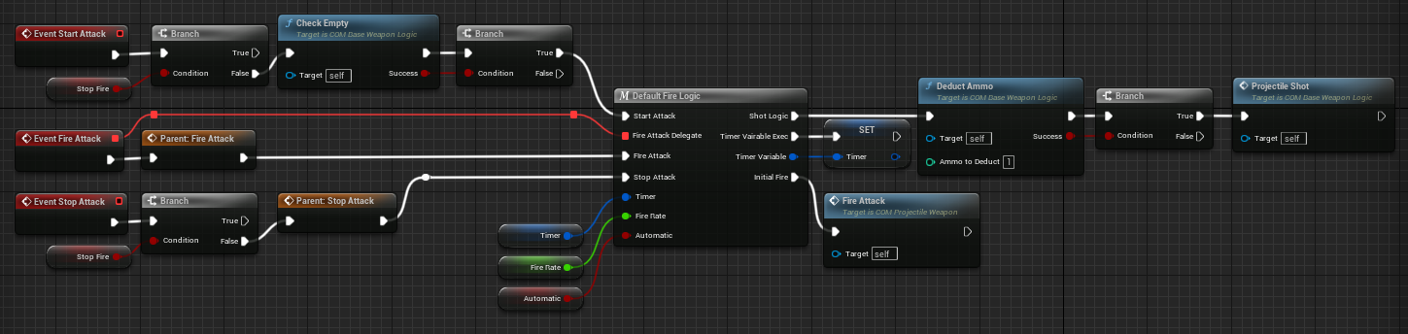
To create a different weapon the above functionality could be copy and pasted and the final function swapped out for an alternate firing mechanic, or an optional addition could be added between the fire logic and ammo deduction function.

Projectile
The projectile has been set up in preparation for a parent child logic system, however the main intention of this is to allow for different particles, materials or meshes to be implemented for alternate projectile types. The intention is to keep the logic the same for each instance.

Expanding the system
This system can be expanded by adding a Niagara system component to allow for alternate effects to be displayed on the fired projectile, it can also be expanded through the parent child hierarchy system by altering the material, mesh, hit effect or hit decal to help the projectiles feel different and unique.

Weapon Pickup & Chest
This section covers the world elements of the system.

Pickup
The pickup can be positioned within the game world, allowing the player to collect it only once per instance. Alternatively, it can be automatically spawned by the chest. While the game loop does not include weapon pickups in the world, the function exists to aid in debugging.
If desired, a pickup placed in the world can be manually configured to spawn a specific weapon instead of generating a random one. Again to assist with debugging any created data assets.

Chest
The chest must be placed in the level as it is tied directly into the wave manager system. All referencing will be handled automatically.

Menu Chest
The menu chest can be placed in the hub, or used for debugging, it will continuously spawn new random weapons any time one is collected.

